EECS 3482

Lab 4:

Mac Policies

Professor: Khalil Abuosba

Student Number: 212779997

Name: Zamir Lalji

Due Date: Mar. 9th 2019

(Note for the marker: Below you will screenshots of what is needed to show the steps that were asked in the lab manual and all the questions were done on kali linux)

Part 1:

Screenshot:for Q3.2

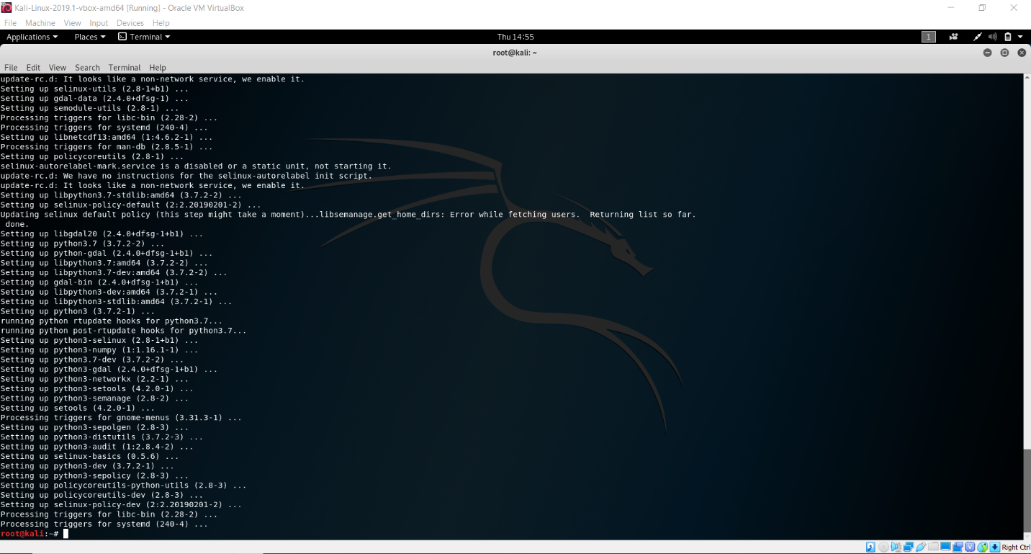

Screenshot for Q3.3:



Screenshot for Q4.1:

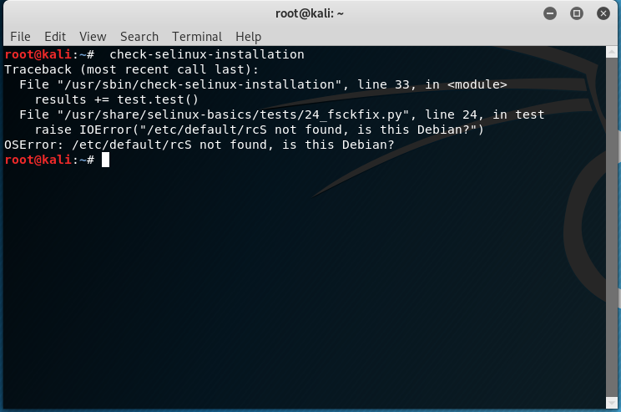

Screenshot for Q4.2:

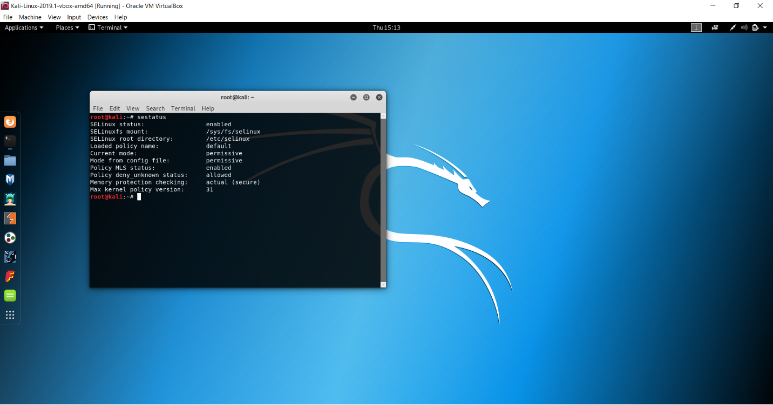

Screenshot for Q4.3-4.6:

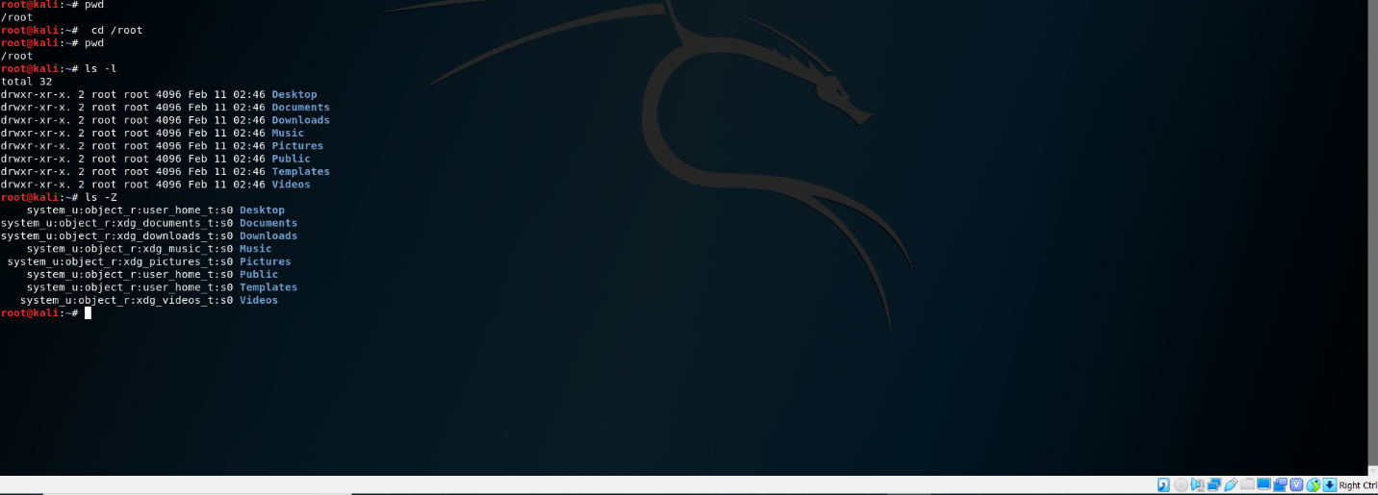

Screenshot for Q5.1-5.2:

5.1: Current Status of SelLinux: is permissive.

5.2: Current status of SelLinux: Default.

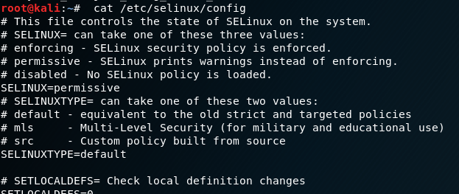

Screenshot for Q6:

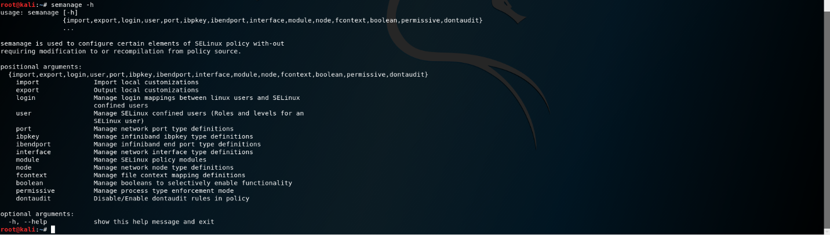

Screenshot of Q7:

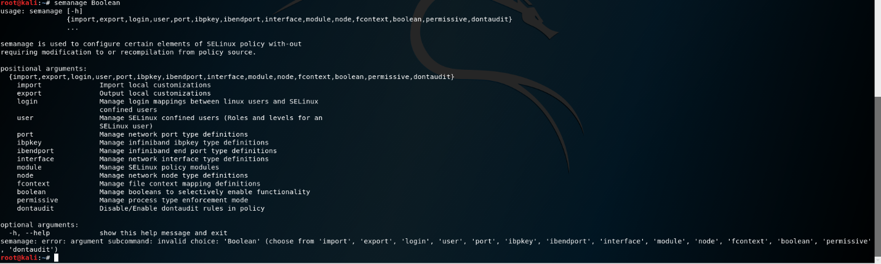

8.1: fenced-can_ssh: (off, off) determined whether fenced can use ssh. Below is a screenshot:

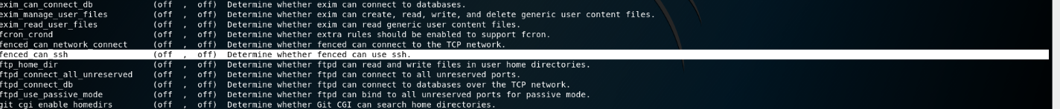

8.2 Current value of the user_ping process is (off, off) Controls user use of ping and traceroute.

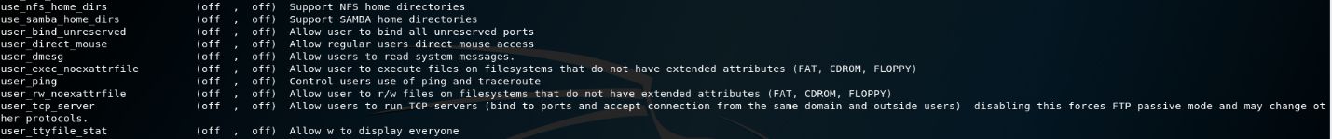

ScreenShot for Q 8.3: 

Screenshot for Q9-Q13:



Screenshot for Q14:

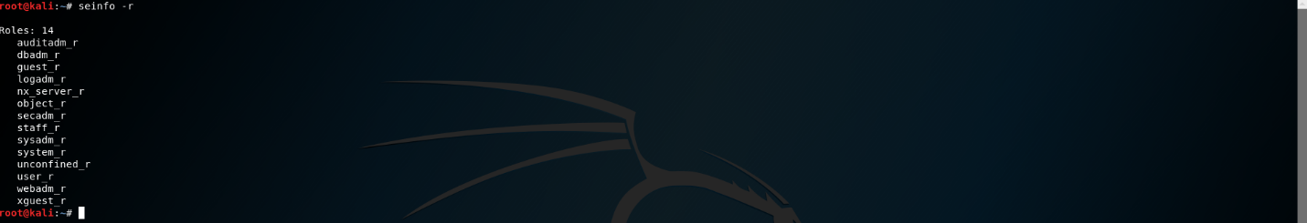

Part2:

Screenshot for Part 2 #1-4:



Screenshot for part 2 #5: 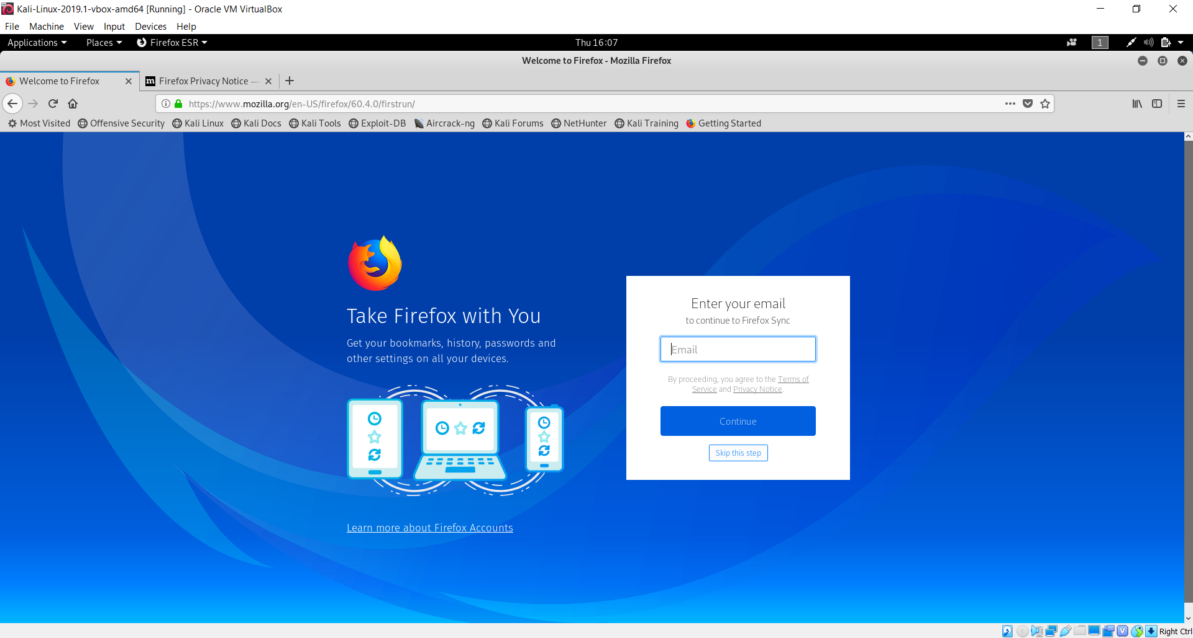

Screenshot for Part 2 #6-7:

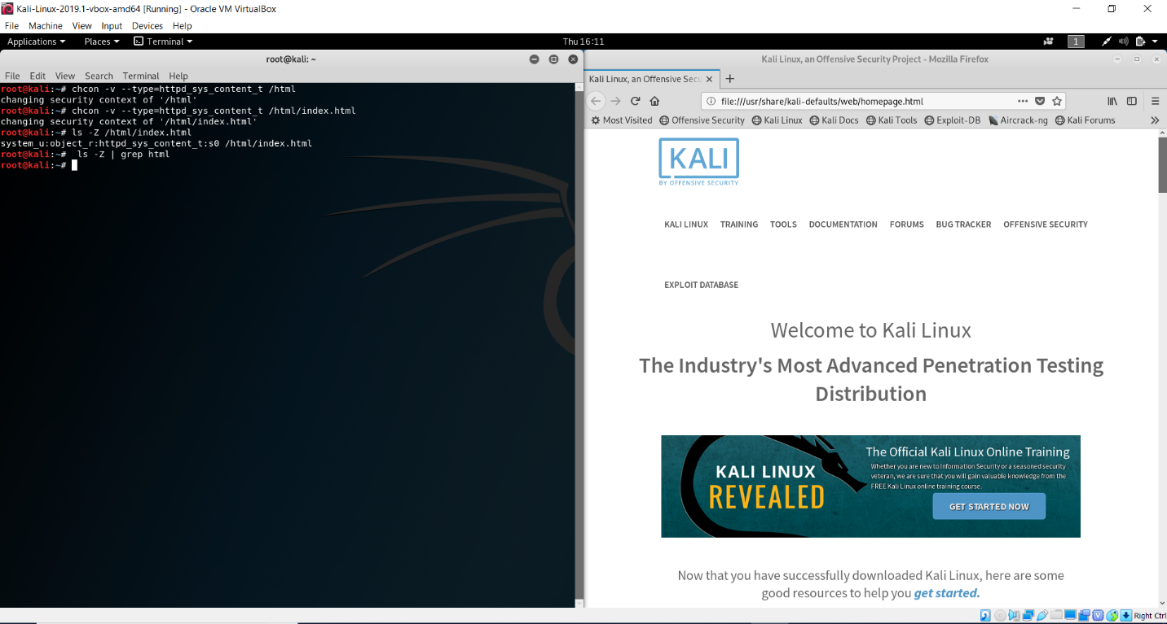

Screenshot for Part 2 #8a:

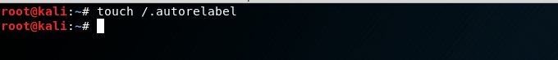

Screenshot for Part 2 #8b-d:

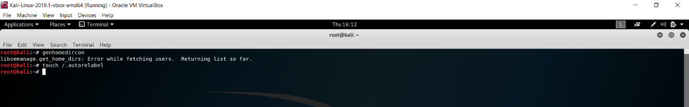

Screenshot for Part 9a:

C:\MyFiles\unnamed (10).png

Screenshot for Part 9b:

